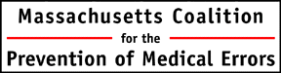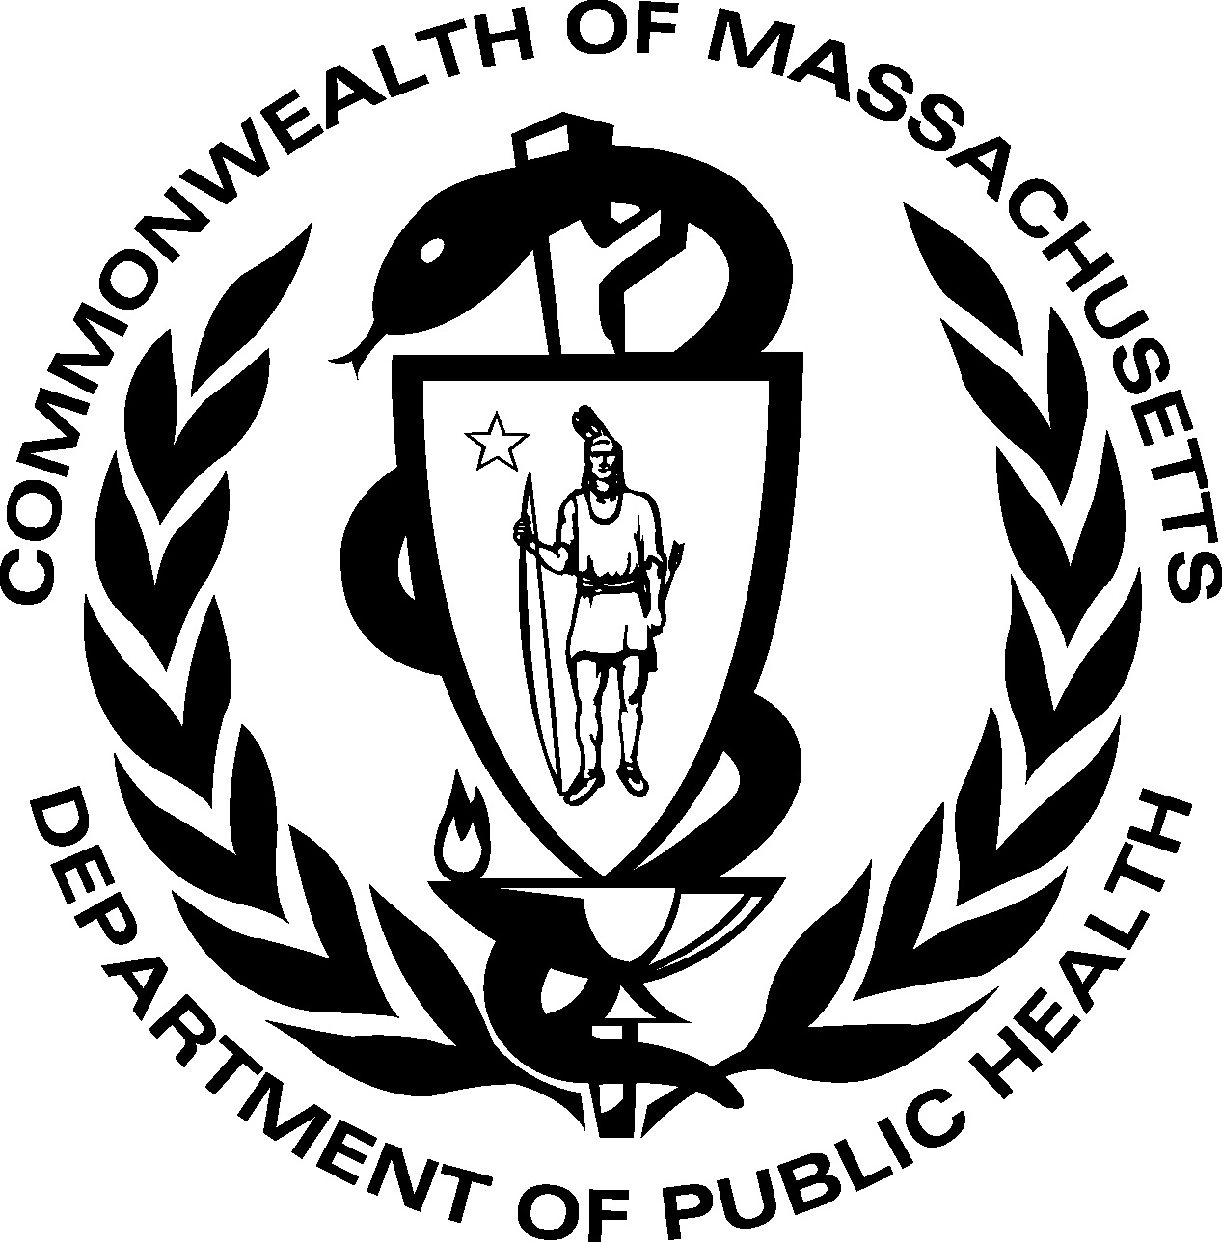

Improving Evaluation & Treatment of UTI in the Elderly:
a Cross-Continuum Approach to Antibiotic Stewardship

Decreasing Inappropriate Treatment of Asymptomatic Bacteriuria
Overview of UTI, Antibiotic Stewardship, & Program Tools | 8-8:10 | Paula Griswold, MS  Massachusetts Coalition for the Prevention of Medical Errors  Irene Campbell, RN, NP  Helen Magliozzi, RN, BSN  Massachusetts Senior Care Association  Eileen McHale, RN  Massachusetts Department of Public Health
To Treat or Not to Treat: That is the Question | 8:10-8:50 | Ruth Kandel, MD  Director, Infection Control  Hebrew SeniorLife
Antibiotic Stewardship and the Misdiagnosis of UTI | 8:50-9:40 | Daniel Pallin, MD, MPH  Director of Research, Department of Emergency Medicine  Brigham & Women’s Hospital
Communicating Across Settings | 9:40-10:10 | Paula Griswold, MS
Break | 10:10-10:30
Prudent Use of Antibiotics in Long Term Care Residents with Suspected UTI | 10:30-11:10 | Shira Doron, MD  Antimicrobial Steward  Associate Hospital Epidemiologist  Division of Geographic Medicine and Infectious Diseases  Tufts Medical Center
Strategies to Support Change in Your Facility | 11:10-11:40 | Susanne Salem-Schatz, Sc.D  Program Director  Massachusetts Coalition for the Prevention of Medical Errors
Lunch | 11:40-12:30
Materials to Support Change  - Clinician Education Sheet  - Education Brochure for patients/residents/family members  - UTI Protocol | 12:30-1:30 | Daniel Pallin, MD, MPH  Ruth Kandel, MD  Susanne Salem-Schatz, Sc.D
How Do We Know We Are Improving? Why Measurement Matters and How We Will Help. | 1:30-2:00 | Paula Griswold, MS  Nora McElroy, MPH  Massachusetts Department of Public Health
Bringing it Home:  What Can We Do by Next Week | 2:00-2:30 | Susanne Salem-Schatz, Sc.D

Nursing CEUs: We will distribute a link for an electronic survey after today’s program. Certificates will be sent out by Coalition staff after survey completion. They will not be automatically generated by the survey website.
Physician, Pharmacy, Nursing Home Administrator, and Allied Health CMEs: You must complete and return a hard copy evaluation at the registration desk before leaving the program. You will receive your certificate electronically from Coalition Staff.
Please contact Fiona Roberts with any questions, froberts@macoalition.org or 781-262-6080.

